1. **Remove   
    Background image and use provided zip file image**
2. **Login change  
     
   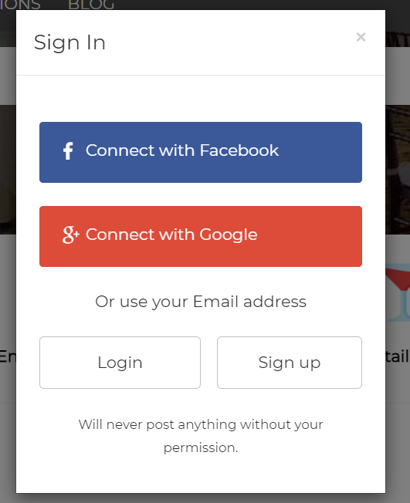**

**User can Singup by above way.  
Option - connect with facebook or google  
Option - user email or Mobile  
  
For login as well as signup both**

1. **Remove About Us tab**
2. **Add blog tab**
3. **Get free quote →> select budget range**

**Budget range should be whole event budget . like 20K - 30K, somthings  
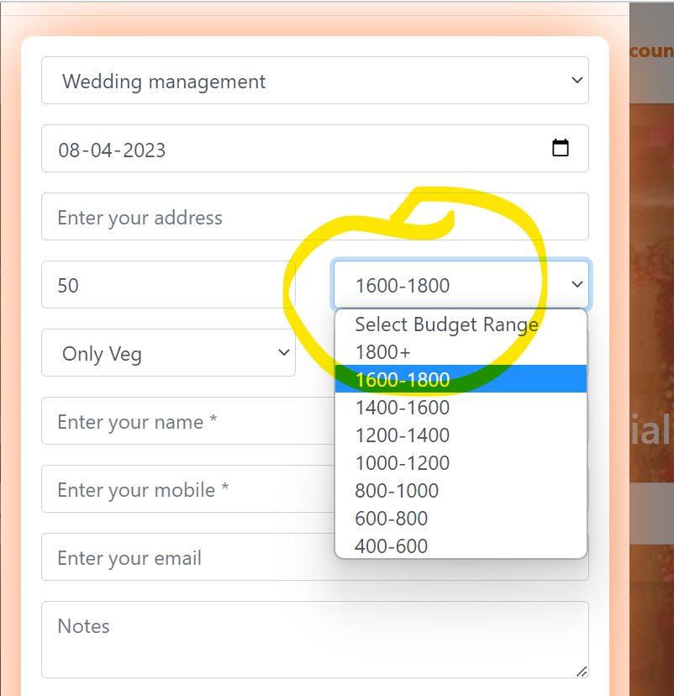**

1. **Change order as below   
   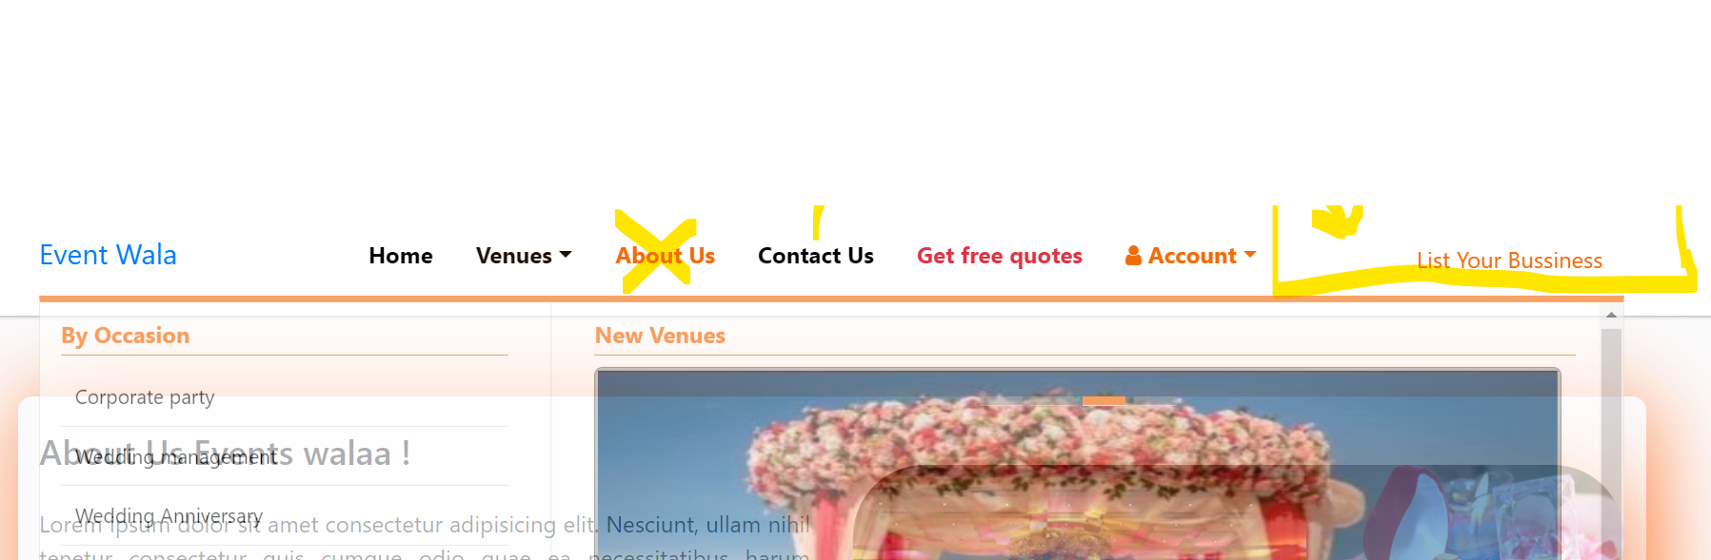**
2. **Remane Contact Us —-------------->> Customer support**
3. **Remane Get free Quote —---->> Get Free Estimatation**